## Premium Modular Smartphone

### Two-Variant Engineering Concept

**Variant A: Aluminum Unibody**  
**Variant B: Ultra-Hard 30X Cold-Rolled Stainless Steel (HFS)**

## 1. Introduction and Project Objective

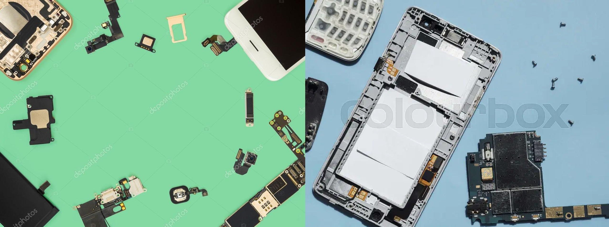The contemporary smartphone market is defined by short product lifecycles, limited repairability, and sealed constructions based on adhesives and permanently soldered components.  
This engineering project proposes a **premium modular smartphone platform** that restores serviceability and long-term usability without sacrificing rigidity, aesthetics, or flagship-level build quality.

The device is designed in **two enclosure variants**, sharing the same internal modular architecture:

* **Variant A:** High-strength aluminum unibody
* **Variant B:** Ultra-hard 30X cold-rolled stainless steel (HFS)

Target lifespan exceeds **10 years**, with upgradeable internals and long-term OS support.

## 2. Core Design Assumptions (Common to Both Variants)

* Premium metal unibody construction
* No structural adhesives in major assemblies
* Fully modular subsystems:
  + CPU / GPU
  + RAM
  + Mass storage
  + Battery
  + Display
  + Camera modules
* Tool-based disassembly using standard service tools
* Android and Linux OS compatibility
* Sustainability-focused design with reduced electronic waste

## 3. Enclosure Design – Two Material Variants

### 3.1 Variant A – Aluminum Unibody Enclosure

**Material:**  
7000-series aerospace-grade aluminum alloy

**Characteristics:**

* Low mass
* Excellent thermal conductivity
* High stiffness-to-weight ratio
* Mature CNC manufacturability

**Structure:**

* CNC-machined aluminum frame
* Removable aluminum rear cover
* Torx micro-screws with magnetic alignment pins

This variant prioritizes **ergonomics, thermal efficiency, and weight optimization**.

### 3.2 Variant B – Ultra-Hard 30X Cold-Rolled Stainless Steel (HFS)

**Material:**  
Patented ultra-hard 30X cold-rolled stainless steel (HFS – Hard Freaking Stainless)

**Characteristics:**

* Extremely high tensile strength
* Exceptional impact and deformation resistance
* Superior scratch and wear resistance
* Increased mass for maximum rigidity

**Structure:**

* Precision cold-rolled stainless steel unibody
* Mechanically locked rear cover (screw + latch system)
* Reinforced internal mounting rails

This variant targets **maximum durability and professional / extreme-use scenarios**.

## 4. Sealing and Environmental Protection

Both variants use identical sealing architecture:

* Silicone gasket between frame and rear cover
* Elastomer seals around ports, buttons, and speakers
* Target ingress protection: **IP67**

Environmental sealing is achieved **without adhesives**, preserving full serviceability.

## 5. Internal Architecture

### 5.1 Layered Modular Layout

The smartphone uses a **vertical layered architecture** designed for:

* Short signal paths
* Efficient thermal transfer to the metal enclosure
* Easy access to all modules

All components mount to a **central backplane board**.

### 5.2 Backplane Board

The backplane is a **non-obsolescent core**, responsible for:

* Power delivery and voltage regulation
* High-speed buses: PCIe, USB, I²C, SPI
* Inter-module communication
* Antenna and I/O integration

CPU and RAM are **excluded** to avoid forced obsolescence.

## 6. Modular Subsystems

### 6.1 Processor & Graphics Module (SoM)

* Replaceable System-on-Module
* Slot-based installation
* ARM and RISC-V support
* Direct thermal interface to metal frame

### 6.2 RAM Module

* Replaceable LPDDR module
* 8 / 16 / 32 GB options

### 6.3 Mass Storage

* NVMe M.2 2230 SSD
* 256 GB – 2 TB
* User-replaceable

### 6.4 Battery Module

* Removable battery cartridge
* Guided rails + magnetic connector
* Multiple capacities supported

### 6.5 Display Module

* OLED / AMOLED
* No adhesive mounting
* 60–144 Hz support

### 6.6 Camera Modules

* Independent main / ultra-wide / telephoto units
* Separate connectors and brackets
* Selective upgrade capability

## 7. Operating System Compatibility

* Android (AOSP)
* Linux-based mobile OS (e.g. postmarketOS)

Hardware modularity enables **software longevity independent of hardware refresh cycles**.

## 8. Comparative Summary

| Feature | Aluminum Variant | HFS Variant |
| --- | --- | --- |
| Weight | Lower | Higher |
| Thermal Conductivity | Excellent | Moderate |
| Impact Resistance | High | Extremely High |
| Scratch Resistance | Moderate | Exceptional |
| Structural Rigidity | High | Extreme |
| Target User | Premium consumer | Professional / industrial |

## 9. Benefits Analysis

* Major reduction of electronic waste
* Lower total cost of ownership
* Decade-long usable lifespan
* User-controlled performance evolution
* Simplified servicing and repair
* Premium build quality without compromise

## 10. Conclusion

This two-variant engineering concept demonstrates that **modularity and premium construction can coexist**.  
By combining a unified modular internal architecture with two radically different enclosure materials, the platform (Aluminum & HFS) addresses diverse user needs while remaining future-proof, sustainable, and mechanically uncompromising.